

FCA AWS Devops bootcamp -

ProjectS Design SpecIFICATION

Contents
Purpose of this document 3
Version History 3
Referenced Documents 3
Client Contacts 3
Overview 4
Scheme of Learning 5
Technical Scheme Of Learning 6
Project Plan 7
Skill Set 9
Skill: Create Schema from provided mySQL files 9
Skill: Access mySQL from python file 9
Skill: Build Flask Application 9
Skill: Containerise Flask Application 9
Skill: Control Containers with Python 9
Skill: Create GitHub Repo for Jenkins to pull down 9
Skill: Create AWS Account and Virtual machine 9
Skill: Deploy Github repo through AWS 10
Skill: Test CI/CD elements of AWS deployment 10
Minimal Viable Product 10
Project 1 (Flask & SQL) Design SpecIFICATION 11
Project 2 (Docker / NExus Pipeline) Design SpecIFICATION 11
Project 3 Design SpecIFICATION 11
VM Requirements 12

Purpose of this document
This document provides the project design specification Examples.

Version History
Ver# | Name | Date | Content Created / updated | Peer Reviewed by | Date
1 | Andry Smith | 27/03/2023 | Document Created

Referenced Documents
# | Name | Version | Date

Client Contacts
Name | Role | Email/Phone

Overview
Background
FCA has requirements to train new graduates into DevOps Engineering roles. They will be working on AWS configuration and deployment. The level expected after training will be foundational. After they complete their graduate scheme, they should be able to apply for formal DevOps engineers within 18 months to 2 years.

Program Type
GRADUATE: The program will be wrapped around a contextualized use case with incremental projects.

Delivery Methods
Delivery will be virtual and Instructor Lead that includes project supervision.

Classroom Environment and Equipment Requirements

Classroom Environment: Virtual
Laptop/PC: Windows 10 or later, 16GB
Network Access: Learner Laptop can connect to GOTOMYPC and GitHub

Audience
Level of understand: Delegates will be graduates
Demographics: Learners will be graduates from different disciplines
Number:

Assumptions
- Delivery will be in English, and all learners will have a good grasp of the language.
- Delegates can create GITHUB account with their own emails.
- Delegates will be graduates who have been through Agile and Project Management training

Scheme of Learning

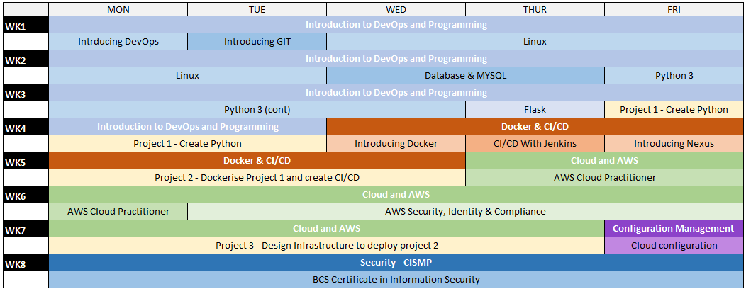

Technical Scheme Of Learning
The core bootcamp aims to provide delegates the necessary expertise to become a skilled AWS DevOps Engineer via contextualized learning. Delegates will build up their knowledge by applying what they learn throughout the program in a program in a series of projects for a case study.

Project Plan
The bootcamp revolves around a case study of developing a WEB Service that will be deployed to AWS. The program consists of three dedicated project lab stages that mimic a DevOps life cycle from Application Development, CI/CD and Deploying to the Cloud.

Objectives
Bring together the key learning activities and support delegates in consolidating their learning.
- Provide opportunity for delegates to apply the learning.
- Allow delegates to demonstrate their knowledge and understanding of the key topics and progress made during the learning pathway prior to returning to the workplace.
- Leave delegates with a model example that they have built and can be referenced in the future to support learning reinforcement.
- Enable delegates to work through some of the abstract concepts that have been covered in the formal learning sessions and be supported in translating their knowledge to new situations.
Approach
The labs will be semi-structured with expected outcomes, but the delegates will have the flexibility to design and build the solution as they believe is most suitable.
- The labs are designed to expose delegates to an Agile delivery methodology alongside the technical topics and they will be expected to demonstrate how they have built the solution and not just what they have built.

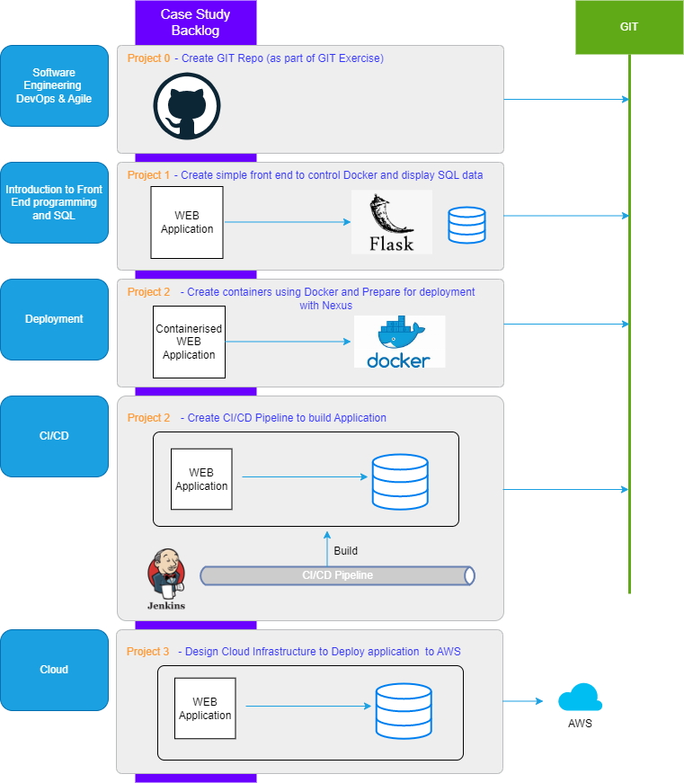

Skill Set
The project revolves around reporting simple SQL results on a Flask front end, building a docker container to host alongside Nexus. Finally deploying to the Cloud using AWS EC2:

Skill: Create Schema from provided mySQL files
Create database Schema and tables
Given install of mySQL
When Files are provided and run
Then schema, tables and records are created

Skill: Access mySQL from python file
Access local running install of mySQL
Given install of VSCode, python and mySQL
When python file is run
Then content is displayed

Skill: Build Flask Application
Create Simple Flask App
Given install of VSCode, python and mySQL
When user opens flask App, content from the provided database
Then content is displayed

Skill: Containerise Flask Application
Run Docker and serve up flask app in a browser
Given install Docker
When user container is started
Then Flask Webpage is displayed

Skill: Control Containers with Python
Start and stop contains using python script and images
Given completed python code
When user runs program
Then specified docker containers are spun up

Skill: Create GitHub Repo for Jenkins to pull down
Create Artifacts (exe, website, app)
Given complete code from Project 1
When used fires Jenkins action
Then source code is pulled from github and Prepared by Jenkins / Nexus

Skill: Create AWS Account and Virtual machine
Prepare environment for application deployment (CI/CD)
Given completed account setup
When user starts EC2 Virtual machine
Then environment is prepared to access artefacts for CI/CD

Skill: Deploy Github repo through AWS
Create AWS EC2 Deployment
Given successful creation of virtual machines
When user fires pipeline
Then content is made available via AWS deployment

Skill: Test CI/CD elements of AWS deployment
Create small changes in SQL data / python code
Given changes in content
When online access to the app is refreshed
Then updated content is displayed

Minimal Viable Product
SQL
- Created schema, tables and records
- Ability to update schema on demand
Python
- Script is able to access local mySQL install
Flask
- Simple front end is created that displays the records in the database in a meaningful manner
- Refreshes view in response to changes in back end data
Docker
- Images downloaded and installed that allow python flask to be containerised
- Images downloaded to allow python to manage other docker containers
Deployment
- Jenkins pulls down working flask code, builds and integrates with nexus
AWS
- Hosts and responds to updates from CI/CD Pipeline

Project 1 (Flask & SQL) Design SpecIFICATION
Design and create web application reference that illustrate:
- Installing mySQL and opening SQL files to create schema, tables and records
- VSCode use and python files that access mySQL data
- Install of Flask and the creation of an app that displays records from MySQL
- Store code in GIT

Project 1 Designer should provide:

- Lesson plan
- LAB requirements
- Reference Code
- Learners Guidelines
- LAB Instruction

Project 2 (Docker / NExus Pipeline) Design SpecIFICATION
Design and create a structure that illustrates
- Pulling down Repo from Github
- Installing Docker / Ubuntu
- Hosting Flask applications in Docker
- Installing images and controlling docker with python script
- Working with error handling
- Creating artifacts in Jenkins and Nexus

Project 2 Designer should provide:

- Lesson plan
- LAB requirements
- Reference Code
- Learners Guidelines / Exercise Guide
- LAB Instruction

Project 3 Design SpecIFICATION
Project 3 is concerned with taking the content created in project 2 and illustrates:
- Creating an AWS user account
- Building a hosting EC2 server for deployment
- Completing deployment for the completed CI/CD Pipelines from project 2
- There are no authentication requirements.
- Live deployment should respond to changes in Jenkins Pipeline

Project 3 Designer should provide:

- Lesson plan
- LAB requirements
- Reference Code

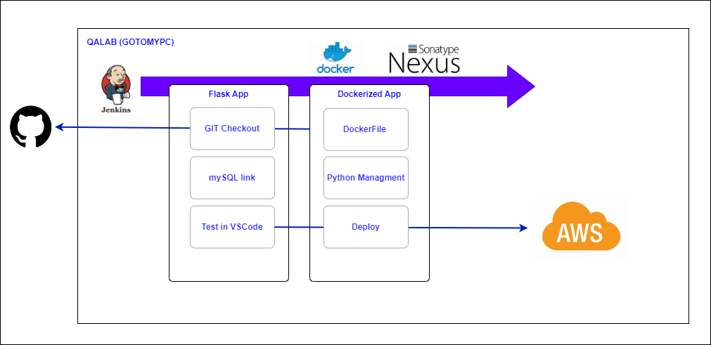

VM Requirements
Software
Delegates will require the following software to be installed on the VMs

- Python 3.10 (minimum)
- VSCode
- mySQL (community)
- mySQL Workbench 8.0 CE
- Ubuntu (minimum V20 – Preferable V22)
- Docker Desktop
- Jenkins (LTS) 2.3x (minimum)

